**Pass Task 5.1 Battleship Project Meeting**

**Meeting Agenda**

Date/Location: 4-Apr-2019 at 1:45 in A302

**Information Updates/Reminders**

* Last week was about analysing the legacy code.
* This week is about converting and documenting the code
* Next week we will use a sprint process over two weeks to fix bugs and extend the project. (No bug fixing or extensions yet!)
* Everyone should be able to use the team git repo, github wiki’s and Trello. Ask for help (tutor or team) if that’s a problem.
* Everyone should have used toggl.com to track their time last week. Also track time on tasks this week with Toggl.
* Tutor must be added to github, trello and toggl.
* The Programming Help Desk ATC620 is *still* available to help us with programming for this unit.

**Decisions Needed**

* Action(s) created to fix missing code documentation (Should not be one person – break into smaller tasks the team can share)
* Action(s) created to confirm converted code works the same as the pre-conversion code (simple functional side-by-side equivalence testing).
* Action(s) to improve the documented list of identified feature issues (Missing, bugs or possible extensions categories)
* Adding in pictures of the bugs to better illustrate the bugs
* Adding in pictures of the functionality issues to illustrate the problem
* Solving the known bugs
* Fix the functionality issues
* Add in extension ideas

**General Items**

* Add tutor account to team tools (github, wiki, toggle)
* Code needs to be converted, and the converted code committed to the repository. (Note – repository must start with VB code.)
* Converted code will need the appropriate SwinGame files to build and run the C# code.
* Missing code documentation (identified by report) needs to be fixed in the converted code. Can be shared by several people
* Converted and running code functionality needs to be checked to make sure it is the same as before (Validation). Suggest a checklist (list of functions?) to document the before and after result.
* There may be missing features, bugs or extension ideas that have not been identified and documented. This will be needed for the up-coming two-week sprint, so we should continue to look for these and note what they are.

**Meeting Minutes**

Date/Location: 28/3/19 at Swinburne University of Technology in A302

Attendees: Marc Chai, Lim Jia Lok, Aldalton Choo

Start Time: [2:30 p.m.]

End Time: [3:30 p.m.]

**Decisions**

* AC,MC and LL will report any other missing code documentation when they find more bugs when trying to fix known bugs.
* AC, MC and LL will run the converted code to confirm converted code works the same as the pre-conversion code (simple functional side-by-side equivalence testing).
* AC, LL and MC will add more known bugs to the documented list of identified feature issues (Missing, bugs or possible extensions categories)
* LL will be adding in pictures of the bugs to better illustrate the bugs
* LL will be adding in pictures of the functionality issues to illustrate the problem
* AC will be fixing the buttons disappearing and making the arrow button point in the correct direction
* LL will be fixing the board being out of bounds and coordinates not labelled correctly.
* MC will do the fixing of score boards not showing and board not functioning properly when clicking on a specific grid.
* AC will be assigning colors to different AIs.
* LL will do the highlighting difficulties chosen by the player and adding the no surrender or quit button in playing interface.
* MC will be assigning different sound effect for AI and players.
* AC,MC and LL will brainstorm to come up with new extensions to be added into the game
* AC should add back in bin and tmp files deleted
* AC will create a new trello board and invite everyone into it for this week's assignment.

**Actions**

* 5-4-19 AC should be done creating the trello board and invited everyone into the project.
* 9-4-19 AC,MC and LL should be able to report any other missing code documentation when they find more bugs when trying to fix known bugs.
* 9-4-19 AC, MC and LL should have run the converted code to confirm converted code works the same as the pre-conversion code (simple functional side-by-side equivalence testing).
* 9-4-19 AC, LL and MC will add more known bugs to the documented list of identified feature issues (Missing, bugs or possible extensions categories)
* 9-4-19 LL should be done adding in pictures of the bugs to better illustrate the bugs
* 9-4-19 LL should be done adding in pictures of the functionality issues to illustrate the problem
* 9-4-19 AC should be done with fixing the buttons disappearing and making the arrow button point in the correct direction
* 9-4-19 LL should be done with fixing the board being out of bounds and coordinates not labelled correctly.
* 9-4-19 MC should be done with fixing the the score boards not showing and board not functioning properly when clicking on a specific grid.
* 9-4-19 AC should be done assigning colors to different AIs.
* 9-4-19 LL should be done highlighting difficulties chosen by the player and adding the no surrender or quit button in playing interface.
* 9-4-19 MC should be done assigning different sound effect for AI and players.
* 9-4-19 AC,MC and LL will brainstorm to come up with new extensions to be added into the game
* 9-4-19 AC should add back in bin and tmp files deleted

**Things I have done**

I have tried to fixed files assigned to me by my group leader and while most of the bugs are fixed some of it is still unfixed because I couldn’t find a solution to fix with it without causing another error in a different file. Most of the bugs that I have occurred in the files above is simple like missing words, capitalization of words that should not be capitalize, missing local variables, methods not called properly, class is not called properly and so on. I have also done adding the bin and tmp files that I have previously deleted because I thought they were of no use, but I was wrong.

**Bugs that I have fixed**

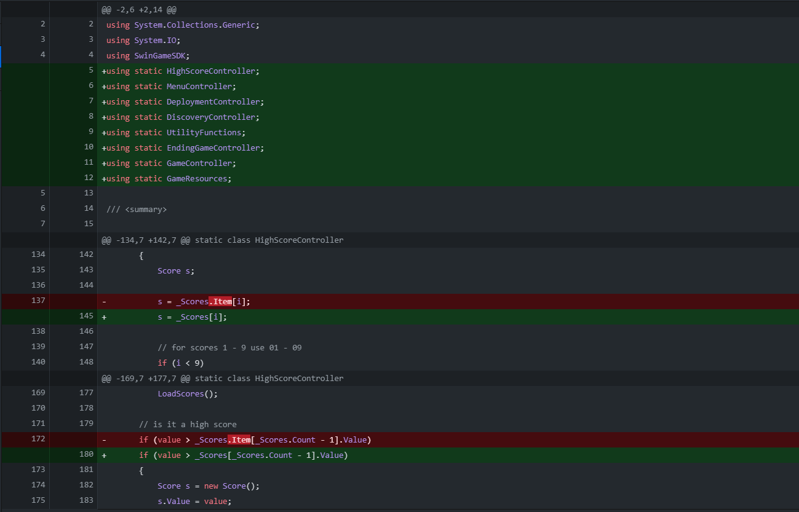

Figure (1) Bugs that I have fixed in HighScoreController file by deleting .Item as in the current context it is not used to access the index in C# and also adding in the files being used at the top.

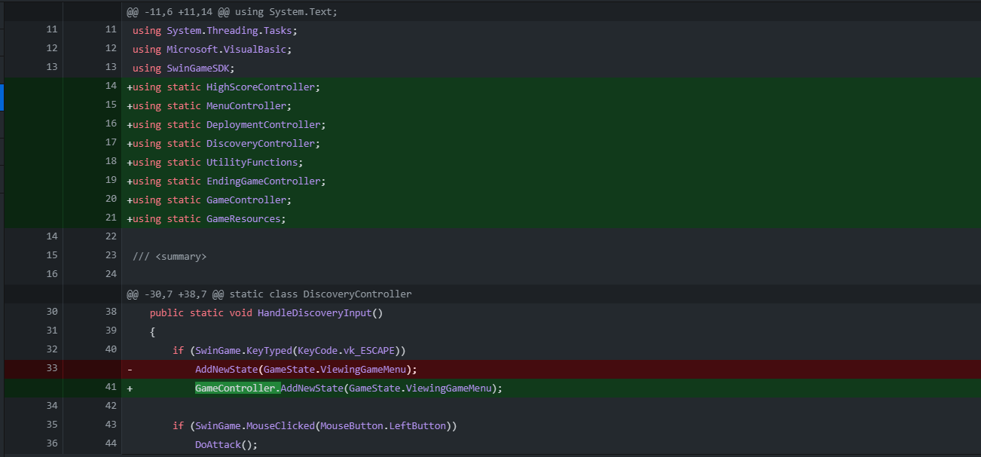

Figure (2) Bugs that I have fixed in Discovery Controller by adding the necessary files that is being used by the DiscoveryController file.

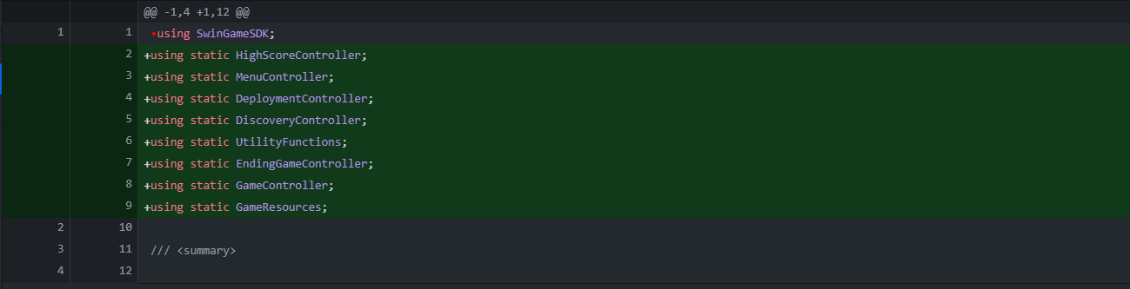

Figure (3) Bugs that I have fixed in EndingGameController by adding the necessary files that is being used by the EndingGameController file.

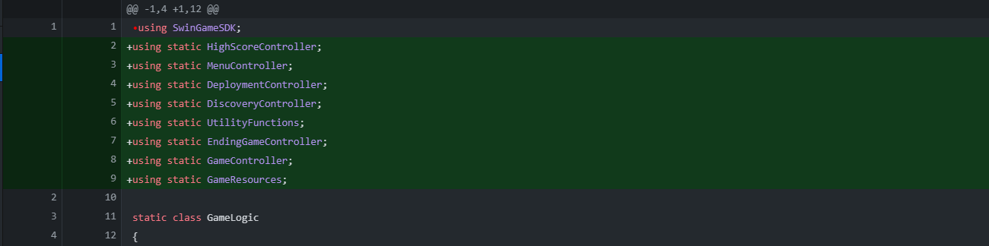

Figure (4) Bugs that I have fixed in GameLogic by adding the necessary files that is being used by the GameLogic file.

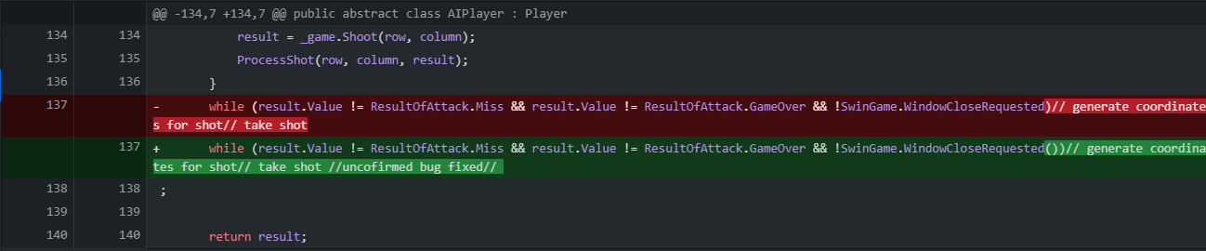

Figure (5) Fixed bugs in AI player file by adding the parentheses at the end of SwinGame.WindowCloseRequested to call the method properly.

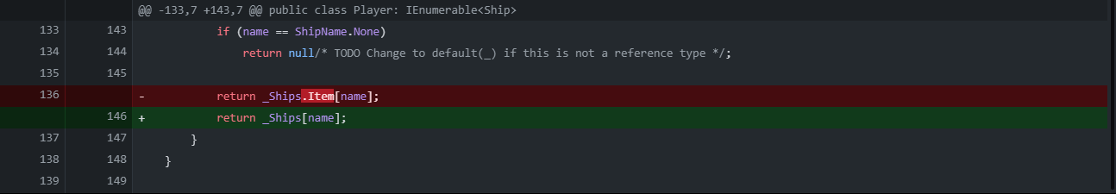

Figure (6) Fixed bugs in player file by removing the .Item as in the current context it is not used to access the index in C#

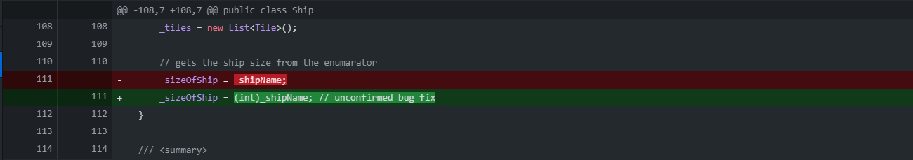

Figure (7) Fixed Bugs in ship file by adding an (int) in front of _shipName because we are trying to convert a string into an int into _sizeOfShip.

**Things that I am currently still doing**

While most bugs are fixed, there are still bugs that I am still currently trying to fix like the bug I have found in the player.cs file. An example of the error can be seen in figure 8 and 9.



Figure (8) error in player.cs file



Figure (9) a more detailed example of the error.

Other than that, we have also tried to run the program after putting a temporary fix on the bugs that we are unsure of if it is the correct way to fix the bug, but we still couldn’t run it. The error that we keep facing is related to the SwinGame.SDK file and the example of the problem can be seen in figure (10)

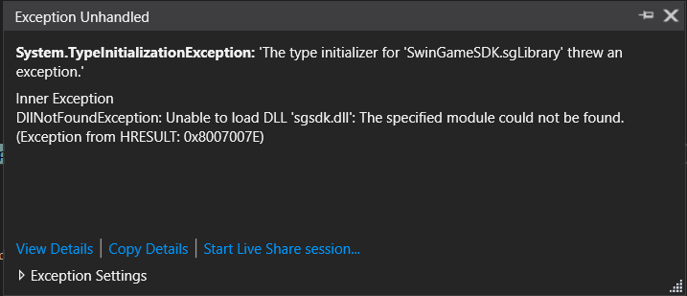

Figure (10) Error shown by the IDE stating that are some problems with the SwinGameSDK.DLL file.

Even after several attempts to fix the following files, we couldn’t find any way to fix it.

**Things that I will be doing in the future**

I will try to work with my team to make the battleship game run so that I can continue to fix on smaller bugs in the game as stated in the meeting agenda above like fixing the arrow not showing in the correct direction, assigning different colors to AIs, and fixing the button disappearing.

**Trello Board**

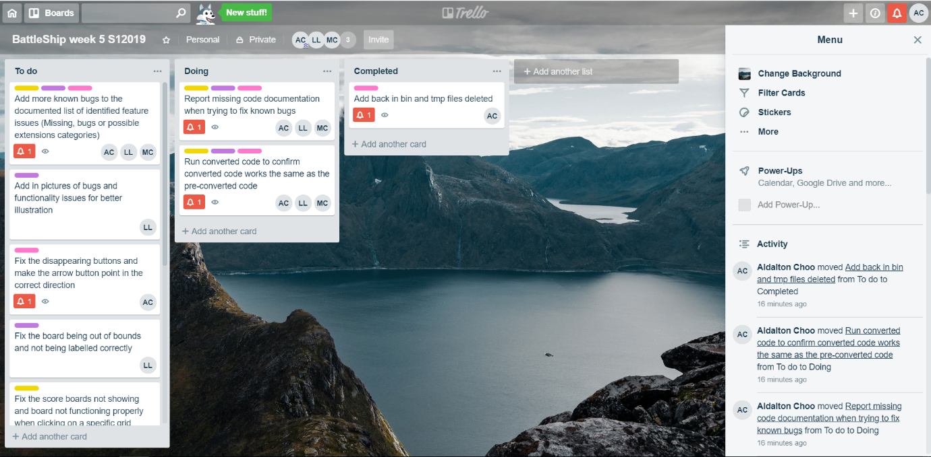

Figure (11) Week 5’s Trello board of the tasks that we have done and currently doing.

**Toggl Board**

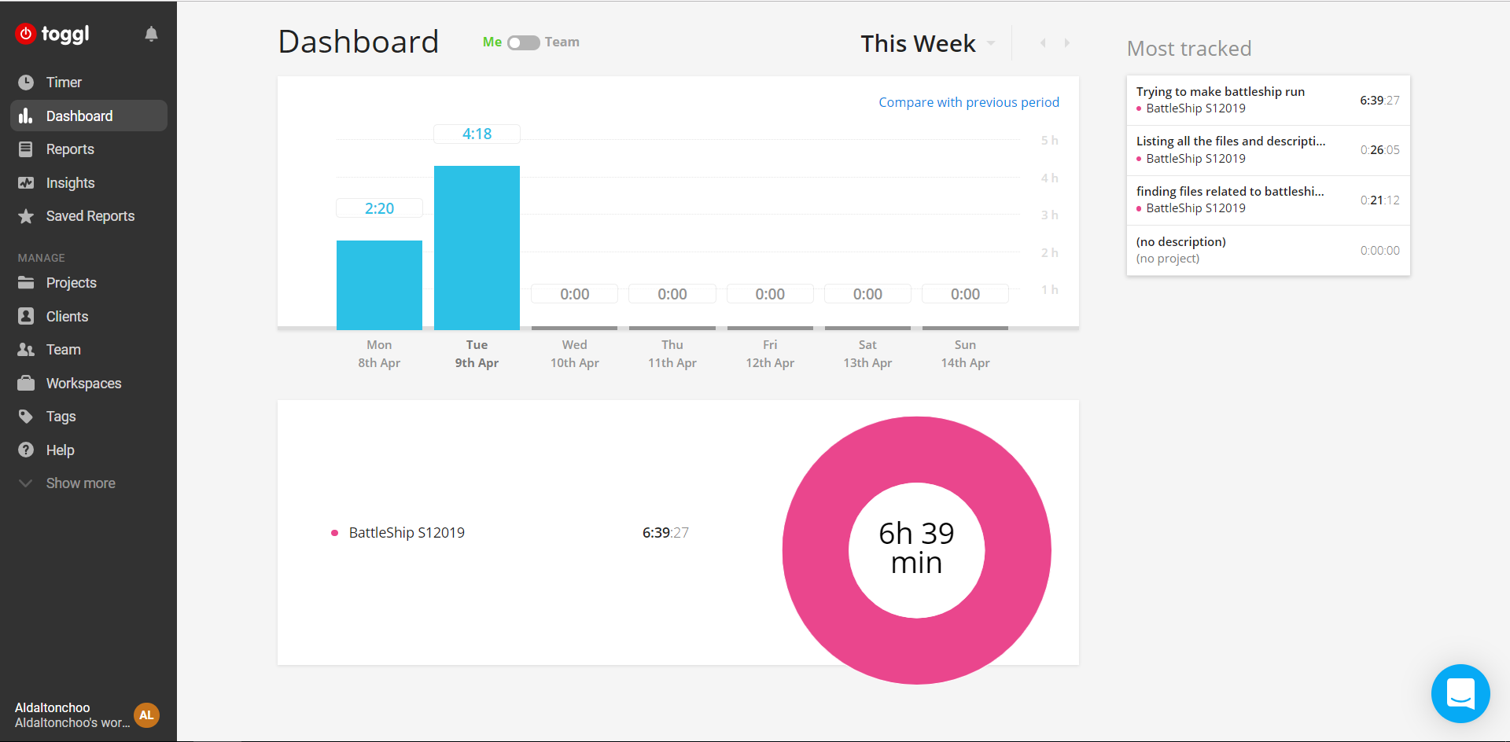

Figure (12) My hours spent on the battleship project for this week.

**Git Hub Contribution graph and Network graph**

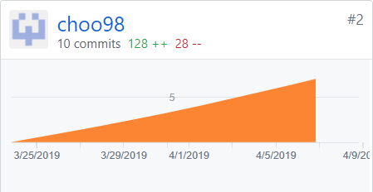

Figure (13) My contribution graph for the battleship project on week 5

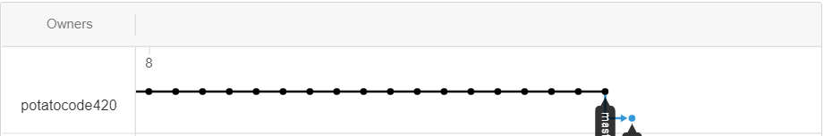

Figure (14) My network graph for the battleship project on week 5